PEORIA POETRY CLUB

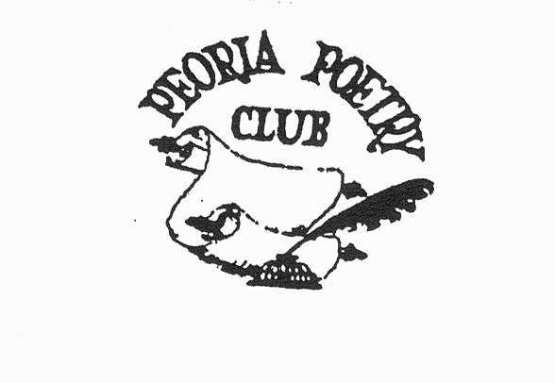

Meeting at:

Illinois Prairie District Public Library

Marcella Schneider Branch, 509 Woodland Knolls Road

Germantown Hills, Illinois 61548

**October 11, 2025**

**Guests (Young and Old) Welcome!**

***FREE!***

11:30 a.m. Meet and Greet (bring a sack lunch if you like)

12:00 Roll Call with members and guests reading

original or favorite poems

1:00 p.m. Program

**Good Poems**

**George Tanner,** published poet and former member of the Peoria Poetry Club, will share and discuss some favorites

and some of his own work.

Bring a poem to share or just come along to listen!

And, if you have published a book or would like to present a future 45-minute program on your particular hobby or specialty, we would like to hear from you!

For more information, leave a message with your phone number

at 309-691-3387 or 309-253-9701