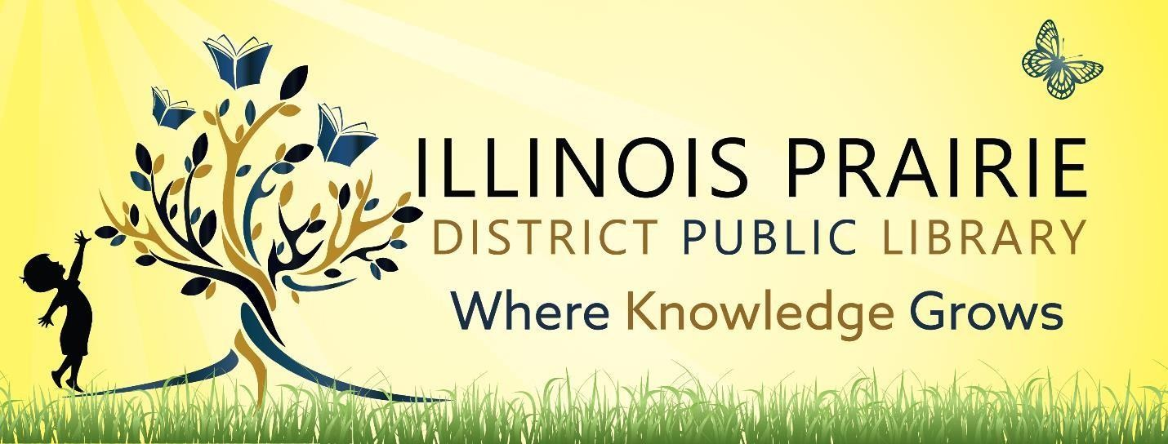

ILLINOIS PRAIRIE DISTRICT PUBLIC LIBRARY BOARD OF TRUSTEES REGULAR BOARD MEETING

Tuesday, October 14, 2025, at

4:00 pm

**Illinois Prairie District Public Library**

**Benson Branch Library**

**420 E Front Street**

**Benson, IL 61516**

1. Call to order and roll call.
2. Minutes of the last regular meeting
3. Public comments
4. Treasurer’s Report – approval of bills and requisitions
5. Discussion and approval of Tax Levy Ordinance 25-3
6. Discussion and approval of Auto-Owners Liability insurance renewal
7. Discussion and approval of Germantown Lots
8. Discussion and Approval of Washburn Branch
9. Director’s Remarks
10. Comments to guide future agendas.
11. Adjournment

The next regular meeting will be on Wednesday,

November 12,2025,

at 4pm at the Metamora Branch Library

208 E Partridge Street

Metamora, IL 61548