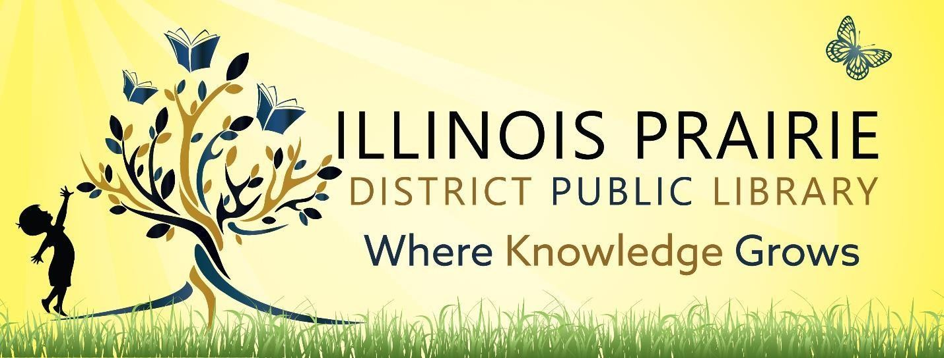

ILLINOIS PRAIRIE DISTRICT PUBLIC LIBRARY BOARD OF TRUSTEES REGULAR BOARD MEETING
Tuesday, October 14, 2025, at
4:00 pm
Illinois Prairie District Public Library
Benson Branch Library
420 E Front Street
Benson, IL 61516

- Call to order and roll call.
- Minutes of the last regular meeting
- Public comments
- Treasurer’s Report – approval of bills and requisitions
- Discussion and approval of Tax Levy Ordinance 25-3
- Discussion and approval of Auto-Owners Liability insurance renewal
- Discussion and approval of Germantown Lots
- Discussion and approval of Memorandum of Understanding with Woodford County Health Department for sharps disposal.
- Discussion and Approval of Washburn Branch
- Director’s Remarks
- Comments to guide future agendas.
- Adjournment

The next regular meeting will be on Wednesday,
November 12,2025,
at 4pm at the Metamora Branch Library
208 E Partridge Street
Metamora, IL 61548

