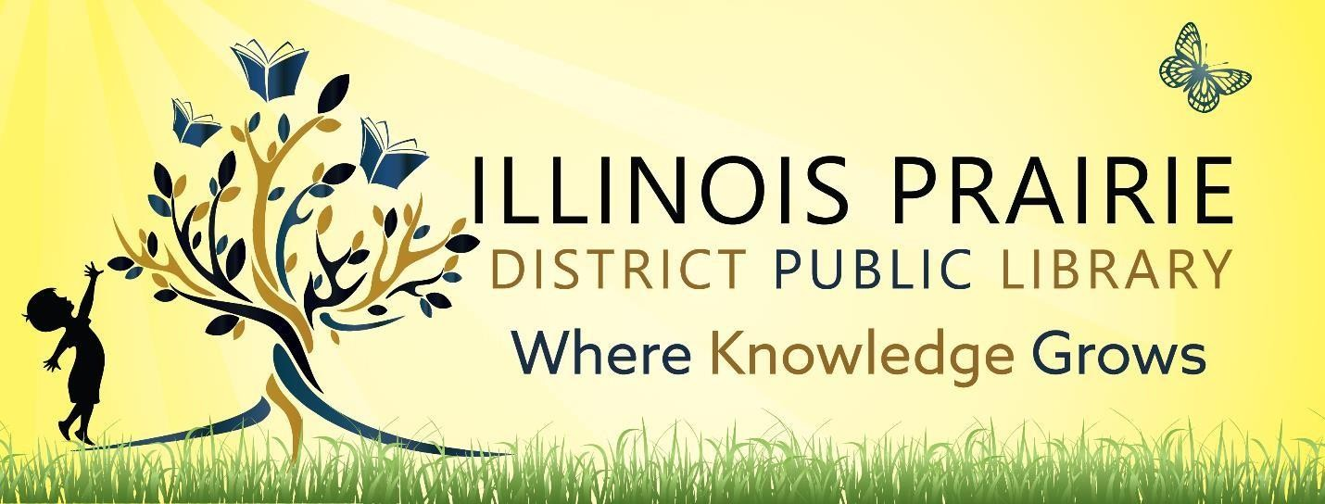

ILLINOIS PRAIRIE DISTRICT PUBLIC LIBRARY BOARD OF TRUSTEES REGULAR BOARD MEETING
on Tuesday,
December 9,2025,
at 4pm at the Metamora Branch Library
208 E Partridge Street
Metamora, IL 61548

- Call to order and roll call.
- Minutes of the last regular meeting
- Public comments
- Treasurer’s Report – approval of bills and requisitions
- Discussion and approval of bids and sale of surplus Germantown Hills lots
- Discussion and Approval of Washburn Branch
- Director’s Remarks
- Comments to guide future agendas.
- Adjournment

The next regular meeting will be on Tuesday,
January 13, 2025,
at 4pm at the Metamora Branch Library
208 E Partridge Street
Metamora, IL 61548

