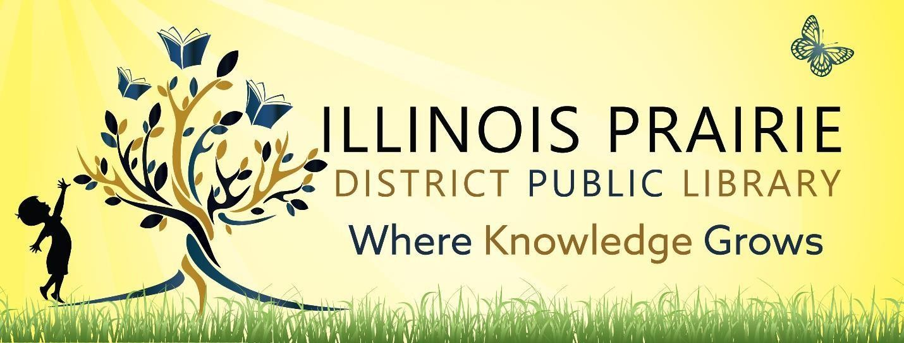

ILLINOIS PRAIRIE DISTRICT PUBLIC LIBRARY BOARD OF TRUSTEES SPECIAL BOARD MEETING
on Monday,
December 22, 2026
at 4pm at the Metamora Branch Library
208 E Partridge Street
Metamora, IL 61548

- Call to order and roll call.
- Public comments
- Discussion and Approval of Washburn branch
- Comments to guide future agendas.
- Adjournment

The next regular meeting will be on Tuesday,
January 13, 2025,
at 4pm at the Metamora Branch Library
208 E Partridge Street
Metamora, IL 61548

