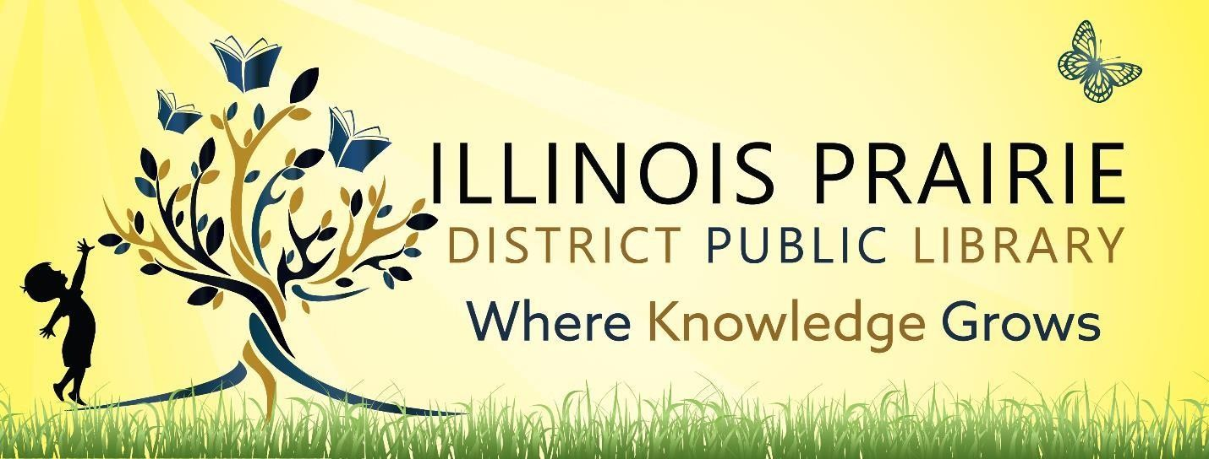

ILLINOIS PRAIRIE DISTRICT PUBLIC LIBRARY BOARD OF TRUSTEES REGULAR BOARD MEETING

Tuesday, May 13, 2025, at

4:00 pm

**Illinois Prairie District Public Library**

**Washburn Branch**

**104 West Magnolia Street**

**Washburn, IL. 61570**

1. Call to order and roll call.
2. Minutes of the last regular meeting
3. Public comments
4. Treasurer’s Report – approval of bills and requisitions
5. Discussion/Review/Approval of closed minutes
6. Discussion and Approval of Library of Things Policy and Waiver
7. Discussion and Approval of Dolly Parton’s Imagination Library Program Sponsorship
8. Discussion and Approval of Designated Charitable Fund Agreement with ILA
9. Discussion and Approval of Washburn branch Property
10. Discussion and Approval of Benson branch
11. Director’s Remarks
12. Comments to guide future agendas.
13. Adjournment

The next regular meeting will be on Tuesday, June 10, 2025,

at 4pm at the Metamora Branch Library

208 East Partridge Street

Metamora, IL 61548