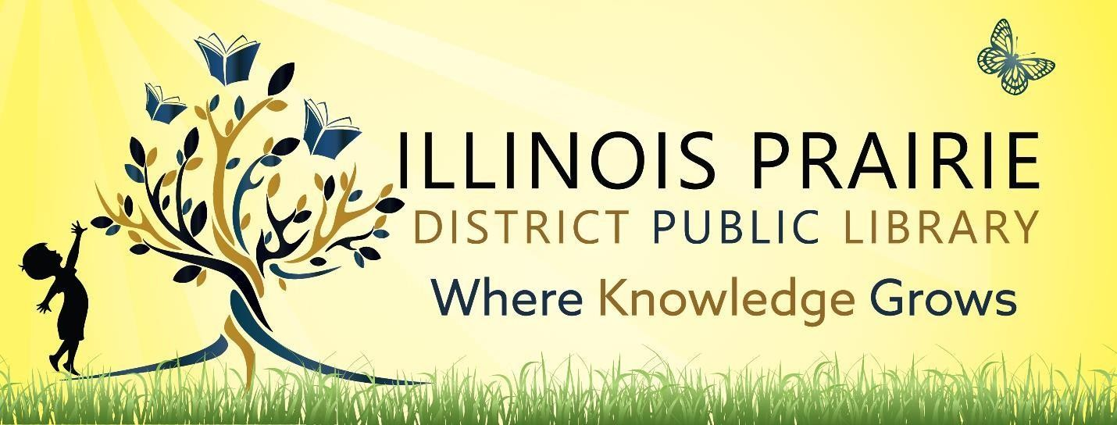

ILLINOIS PRAIRIE DISTRICT PUBLIC LIBRARY BOARD OF TRUSTEES REGULAR BOARD MEETING
Tuesday, June 10, 2025, at
4:00 pm
Illinois Prairie District Public Library
Metamora Branch
208 E Partridge Street
Metamora, IL 61548

- Call to order and roll call.
- Minutes of the last regular meeting
- Public comments
- Treasurer’s Report – approval of bills and requisitions
- Swearing in of Elected trustees
- Reorganization of Board and Election of Officers
- Discussion and Approval of FY26 Salaries
- Discussion and Approval of IMRF Benefits
- Discussion and Approval of Board Meeting Ordinance FY26 (Ordinance 24-5)
- Discussion and Approval of FY26 Nonresident Fee
- Director’s Remarks
- Comments to guide future agendas.
- Adjournment

The next regular meeting will be on Tuesday, July 8, 2025,
at 4pm at the Metamora Branch Library
208 East Partridge Street
Metamora, IL 61548

