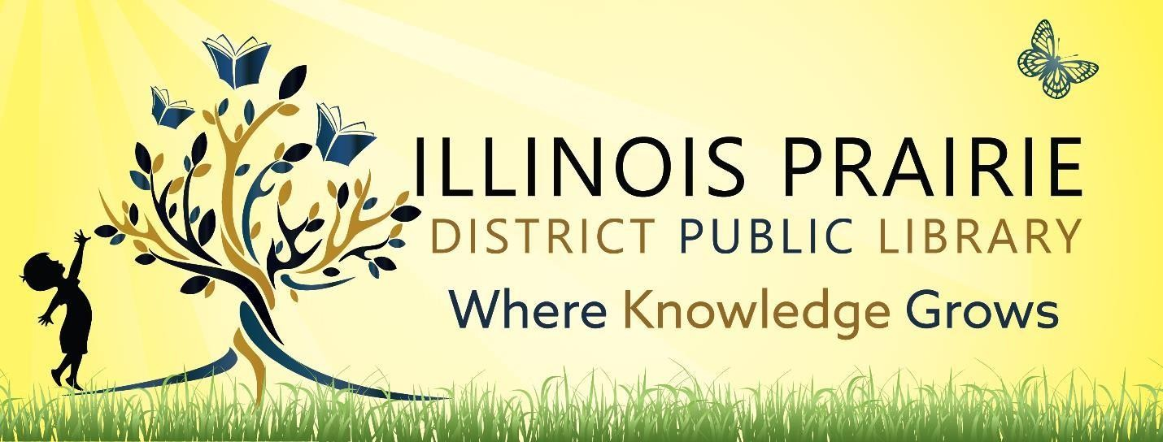

ILLINOIS PRAIRIE DISTRICT PUBLIC LIBRARY BOARD OF TRUSTEES REGULAR BOARD MEETING

Tuesday, July 8, 2025, at

4:00 pm

**Illinois Prairie District Public Library**

**Metamora Branch**

**208 E Partridge Street**

**Metamora, IL 61548**

1. Call to order and roll call.
2. Minutes of the last regular meeting
3. Public comments
4. Treasurer’s Report – approval of bills and requisitions
5. Discussion and Approval of Job Description Change
6. Discussion and Approval of Server Quote
7. Discussion and Approval of Maintenance Ordinance 25-1
8. Discussion and Approval of Dolly Parton’s Imagination Library
9. Discussion and Approval of Washburn Branch
10. Director’s Remarks
11. Comments to guide future agendas.
12. Adjournment

The next regular meeting will be on Tuesday, August 12, 2025,

at 4pm at the Roanoke Branch Library

123 E Broad Street

Roanoke, IL 61561